Constructing Triangle

Definition
# Source: AI Source: Provided by: [Data Path: Persons Table -> ID Column: 1, Name_En Column: Motasem Essam] -> From: [ChatGPT] on [7/25/2026]
Constructing a Triangle is the geometric construction of a triangle from a specified set of geometric information, such as its side lengths, angle measures, or combinations of sides and angles, using classical construction tools such as a straightedge and compass.
A triangle is a polygon with three sides, three vertices, and three interior angles.
$$\boxed{△ABC}$$
For every triangle:
$$\boxed{A+B+C={180}^{∘}}$$
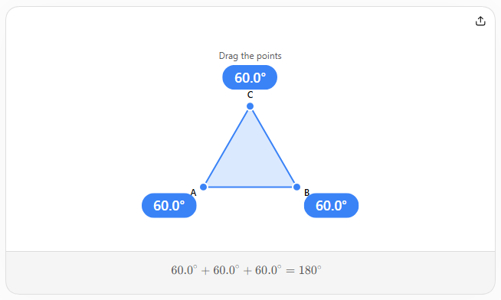

Fundamental Concept
# Source: AI Source: Provided by: [Data Path: Persons Table -> ID Column: 1, Name_En Column: Motasem Essam] -> From: [ChatGPT] on [7/25/2026]
A triangle can be uniquely determined by certain combinations of its sides and angles.
The most important classical triangle-construction cases are:
- SSS — Side-Side-Side
- SAS — Side-Angle-Side
- ASA — Angle-Side-Angle
- AAS — Angle-Angle-Side
- RHS — Right angle-Hypotenuse-Side
These specify enough information to construct a unique triangle, up to congruence, under the appropriate conditions.

Basic Construction Principle
# Source: AI Source: Provided by: [Data Path: Persons Table -> ID Column: 1, Name_En Column: Motasem Essam] -> From: [ChatGPT] on [7/25/2026]
The general process is:
- Identify the given measurements.
- Determine which construction case applies.
- Construct the known side or angle.
- Use the compass to transfer given lengths.
- Construct the required arcs or angles.
- Locate the remaining vertex or vertices.
- Connect the vertices with a straightedge.
- Verify that the constructed triangle satisfies the given conditions.

1. Constructing a Triangle by SSS
# Source: AI Source: Provided by: [Data Path: Persons Table -> ID Column: 1, Name_En Column: Motasem Essam] -> From: [ChatGPT] on [7/25/2026]
Definition
SSS (Side-Side-Side) construction creates a triangle when the lengths of all three sides are given.
Given:
$$AB=c, BC=a, AC=b$$
we construct:
$$\boxed{△ABC}$$
Construction Steps
Suppose the required side lengths are $a$, $b$, and $c$.
- Construct the base:
$$\overset{‾}{AB}=c$$
- With center $A$, draw an arc of radius $b$.
- With center $B$, draw an arc of radius $a$.
- Let the arcs intersect at $C$.
- Connect $A$to $C$.
- Connect $B$to $C$.
The result is:
$$\boxed{△ABC}$$
The construction works because:
$$AC=b, BC=a, AB=c$$
Condition for Existence
The three side lengths must satisfy the triangle inequality:
$$\boxed{a+b>c} \\ \boxed{a+c>b} \\ \boxed{b+c>a}$$
If these conditions are not satisfied, a non-degenerate triangle cannot be constructed.

2. Constructing a Triangle by SAS
# Source: AI Source: Provided by: [Data Path: Persons Table -> ID Column: 1, Name_En Column: Motasem Essam] -> From: [ChatGPT] on [7/25/2026]
Definition
SAS (Side-Angle-Side) construction creates a triangle when two side lengths and the angle between them are given.
Given:
$$AB=c, AC=b, ∠BAC=A$$
Construction Steps
- Construct:
$$\overset{‾}{AB}=c$$
- At $A$, construct the given angle:
$$∠BAC=A$$
- On the new ray, use the compass to mark:
$$AC=b$$
- Connect $C$to $B$.
The resulting triangle is:
$$\boxed{△ABC}$$
The angle must be the included angle, meaning the angle between the two given sides.

3. Constructing a Triangle by ASA
# Source: AI Source: Provided by: [Data Path: Persons Table -> ID Column: 1, Name_En Column: Motasem Essam] -> From: [ChatGPT] on [7/25/2026]
Definition
ASA (Angle-Side-Angle) construction creates a triangle when two angles and the side between them are given.
Given:
$$∠A, AB=c, ∠B$$
Construction Steps
- Construct the given side:
$$\overset{‾}{AB}=c$$
- At $A$, construct angle $A$.
- At $B$, construct angle $B$.
- Extend the two constructed rays.
- Their intersection is $C$.
Therefore:
$$\boxed{△ABC}$$
The third angle automatically satisfies:
$$\boxed{C={180}^{∘}-A-B}$$

4. Constructing a Triangle by AAS
# Source: AI Source: Provided by: [Data Path: Persons Table -> ID Column: 1, Name_En Column: Motasem Essam] -> From: [ChatGPT] on [7/25/2026]
Definition
AAS (Angle-Angle-Side) construction creates a triangle when two angles and one side that is not between the two angles are given.
Given, for example:
$$∠A, ∠B, AC=b$$
Construction Principle
- Construct the given side.
- Construct the first given angle.
- Use the angle-sum property to determine the third angle:
$$C={180}^{∘}-A-B$$
- Construct the necessary second angle.
- The intersection of the constructed rays determines the remaining vertex.
Thus:
$$\boxed{△ABC}$$
ASA vs AAS
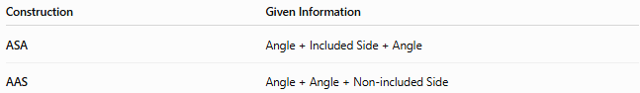
Construction | Given Information
ASA | Angle + Included Side + Angle
AAS | Angle + Angle + Non-included Side
Both determine a triangle uniquely under the usual non-degenerate conditions.

5. Constructing a Triangle by RHS
# Source: AI Source: Provided by: [Data Path: Persons Table -> ID Column: 1, Name_En Column: Motasem Essam] -> From: [ChatGPT] on [7/25/2026]
Definition
RHS (Right angle-Hypotenuse-Side) construction applies specifically to a right triangle.
The given information consists of:
- a right angle,
- the hypotenuse,
- one other side.
For example:
$$∠A={90}^{∘}$$
with:
$$BC=c$$
and:
$$AB=b$$
Construction Principle
- Construct the given side.
- Construct the required right angle.
- Use the compass to transfer the given side length.
- Locate the remaining vertex.
- Connect the vertices.
The resulting triangle is a right triangle.

Classification of Triangle Construction
# Source: AI Source: Provided by: [Data Path: Persons Table -> ID Column: 1, Name_En Column: Motasem Essam] -> From: [ChatGPT] on [7/25/2026]
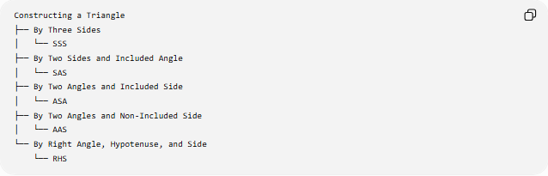
Constructing a Triangle
├── By Three Sides
│ └── SSS
├── By Two Sides and Included Angle
│ └── SAS
├── By Two Angles and Included Side
│ └── ASA
├── By Two Angles and Non-Included Side
│ └── AAS
└── By Right Angle, Hypotenuse, and Side
└── RHS
Important Note About SSA
SSA (Side-Side-Angle) is generally not a standard unique triangle-construction criterion.
In some cases, SSA can produce:
- no triangle,
- one triangle,
- or two different triangles.
This is known as the ambiguous case.
Therefore, SSA should not be treated as a general congruence criterion like SSS, SAS, ASA, or AAS.

Triangle Construction and Congruence
# Source: AI Source: Provided by: [Data Path: Persons Table -> ID Column: 1, Name_En Column: Motasem Essam] -> From: [ChatGPT] on [7/25/2026]
The main triangle-construction criteria correspond closely to triangle congruence criteria.
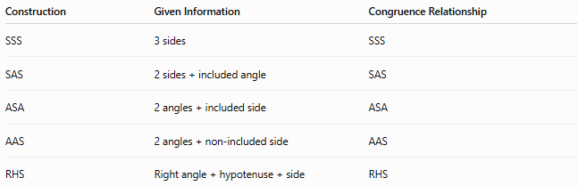
Construction | Given Information | Congruence Relationship
SSS | 3 sides | SSS
SAS | 2 sides + included angle | SAS
ASA | 2 angles + included side | ASA
AAS | 2 angles + non-included side | AAS
RHS | Right angle + hypotenuse + side | RHS
When the required conditions are satisfied, the construction determines a triangle uniquely up to reflection.
For example, an SSS construction may produce a triangle on either side of the base segment, but the two results are mirror images and are congruent.

Triangle Construction Using a Compass and Straightedge
# Source: AI Source: Provided by: [Data Path: Persons Table -> ID Column: 1, Name_En Column: Motasem Essam] -> From: [ChatGPT] on [7/25/2026]
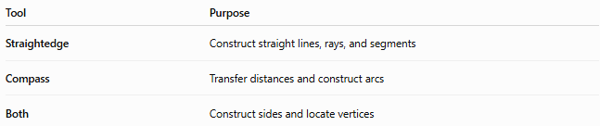
Tool | Purpose
Straightedge | Construct straight lines, rays, and segments
Compass | Transfer distances and construct arcs
Both | Construct sides and locate vertices
The compass is particularly important for:
- transferring side lengths,
- locating vertices,
- constructing circles and arcs.

Example: SSS Construction
# Source: AI Source: Provided by: [Data Path: Persons Table -> ID Column: 1, Name_En Column: Motasem Essam] -> From: [ChatGPT] on [7/25/2026]
Suppose:
$$AB=5\text{ cm} \\ AC=4\text{ cm} \\ BC=6\text{ cm}$$
Steps
- Construct:
$$AB=5\text{ cm}$$
- Draw an arc centered at $A$with radius:
$$4\text{ cm}$$
- Draw an arc centered at $B$with radius:
$$6\text{ cm}$$
- Let the arcs intersect at $C$.
- Draw $AC$and $BC$.
Then:
$$\boxed{AB=5, AC=4, BC=6}$$
so the constructed triangle satisfies all three given side lengths.
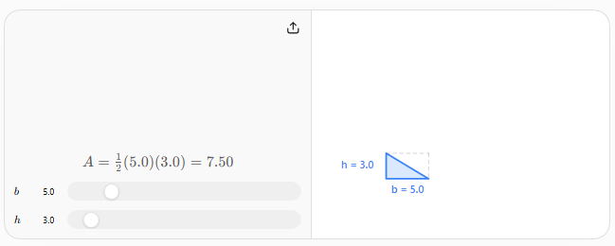
Verification
After constructing a triangle, verify that:
Side Conditions
The required side lengths are satisfied:
$$AB=c, BC=a, AC=b$$
Angle Conditions
The required angle measures are satisfied:
$$∠A=A, ∠B=B, ∠C=C$$
Triangle Inequality
For side lengths $a,b,c$:
$$\boxed{a+b>c, a+c>b, b+c>a}$$
Angle Sum
$$\boxed{A+B+C={180}^{∘}}$$
Special Triangle Constructions
Certain triangles can be constructed using their defining properties.
Equilateral Triangle
All three sides are equal:
$$\boxed{AB=BC=CA}$$
and:
$$\boxed{A=B=C={60}^{∘}}$$
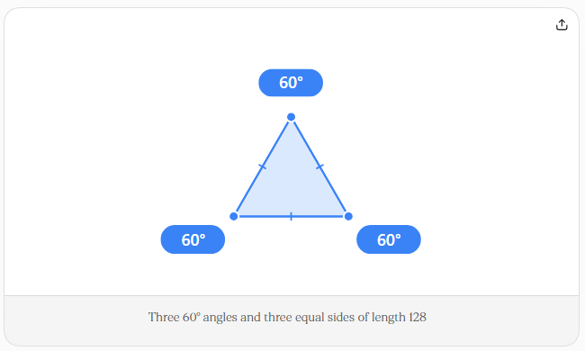
Isosceles Triangle
Two sides are equal:
$$\boxed{AB=AC}$$
Therefore, the opposite base angles are equal:
$$\boxed{∠B=∠C}$$
Right Triangle
One angle is:
$$\boxed{{90}^{∘}}$$
If the legs are $a,b$and hypotenuse is $c$:
$$\boxed{a^{2}+b^{2}=c^{2}}$$
Scalene Triangle
All three sides have different lengths:
$$\boxed{a≠b, b≠c, a≠c}$$

Relationship to Other Geometric Constructions
# Source: AI Source: Provided by: [Data Path: Persons Table -> ID Column: 1, Name_En Column: Motasem Essam] -> From: [ChatGPT] on [7/25/2026]
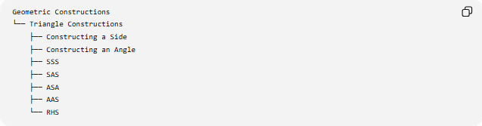
Geometric Constructions
└── Triangle Constructions
├── Constructing a Side
├── Constructing an Angle
├── SSS
├── SAS
├── ASA
├── AAS
└── RHS
Triangle construction combines several previously learned constructions:
- constructing a line segment
- constructing a ray
- constructing an angle
- copying a length
- constructing arcs
- finding intersections
Therefore:
$$\boxed{\text{Triangle Construction}=\text{Segments + Angles + Arcs + Intersections}}$$

Key Points
# Source: AI Source: Provided by: [Data Path: Persons Table -> ID Column: 1, Name_En Column: Motasem Essam] -> From: [ChatGPT] on [7/25/2026]
- A triangle has three sides, three vertices, and three interior angles.
- The interior angles satisfy:
$$\boxed{A+B+C={180}^{∘}}$$
- The principal classical construction cases are:
  - SSS
  - SAS
  - ASA
  - AAS
  - RHS
- SSS uses three side lengths.
- SAS uses two sides and their included angle.
- ASA uses two angles and their included side.
- AAS uses two angles and a non-included side.
- RHS applies specifically to right triangles.
- SSA is not generally a unique construction criterion because of the ambiguous case.
- Compass and straightedge are the fundamental classical construction tools.
- Triangle construction combines basic constructions such as segments, angles, arcs, and intersections.

Conclusion
# Source: AI Source: Provided by: [Data Path: Persons Table -> ID Column: 1, Name_En Column: Motasem Essam] -> From: [ChatGPT] on [7/25/2026]
Constructing a Triangle is the process of creating a triangle from sufficient geometric information using exact construction methods. The principal construction criteria are SSS, SAS, ASA, AAS, and RHS, each specifying a different combination of sides and angles. These constructions combine fundamental techniques such as constructing line segments, copying angles, transferring lengths with a compass, and locating intersections. When the appropriate conditions are satisfied, the resulting triangle is uniquely determined up to reflection.

